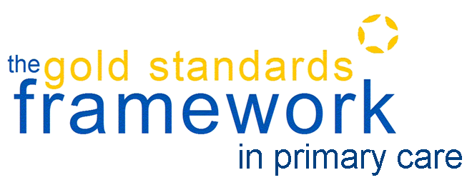
Press Release
EMBARGO: 13:00 27th September 2018

Midlands GP practice named GSF GP Practice of the Year for Gold Standard end of life care
A Midlands GP practice which has almost trebled the number of patients it identifies as being eligible for end of life care and doubled those given an opportunity to help plan their own care, has been named as the first GSF GP Practice of the Year.
Cape Hill Medical Centre in Smethwick, where more than three quarters of the patients on the palliative care register have a non-cancer diagnoses, impressed the Gold Standards Framework Centre judges with its overall success in extending quality end of life care to as many of its patients as possible.
Professor Keri Thomas, Clinical Director of the GSF Centre, said: “We began GSF over 20 years ago to ensure as many people as possible in their final years of life could access compassionate, personalised and proactive end of life care. Cape Hill Medical Centre has really embedded it throughout the whole team and is now celebrated as one of the best examples we’ve seen of a GP practice providing outstanding care for this important patient group.
“Dr Laura Pugh and her team have demonstrated what is possible in terms of identifying more patients in the last year of life from all ethnic backgrounds, with all conditions and in all settings, offering them advance care planning discussions to enable care in line with their preferences and then actually delivering on those wishes. Cape Hill really does stand out as an outstanding practice providing gold standard end of life care and is one that we would recommend all other GP practices emulate.”
Dr Pugh who led the implementation of GSF at the practice, said that the time and effort invested was well worth it. She added: “While a big part of end of life care is about wanting to do it well and provide compassionate care, what GSF has given us is the structure and tools, to deliver better, more coordinated care, not just well-intentioned care. We’re more skilled at symptom management and while delivering better end of life care can take more time, the rewards are great.
“We work in an inner-city area with high deprivation and wide diversity and there are challenges associated with this, but the training has helped us to reach marginalised groups as well as those who find it easy to access services.”
Cape Hill, which has 12,000 patients, five partners and five salaried GPs, increased the number of patients on its register threefold from 45 to more than 130, reaching out to new demographics and people with conditions that hadn’t previously been deemed appropriate for the list. The practice has increased its end of life care identification rate from 0.36% to more than 1%. A total of 78% of patients on the register have a non-cancer diagnosis and nine out ten have an advance care plan. The total number of patients on the register has increased from 45 to 121.
Dr Pugh says: “The most transformative effect we’ve felt from doing GSF has been the organisational impact across the whole surgery – how it has got everyone engaged in the process. It enables everyone in the practice to a higher standard in relation to end of life care.
Dr Victoria Tzortziou-Brown, Honorary Secretary of the Royal College of GPs which co-badges the GSF GP Quality Hallmark Awards, said: “The RCGP continues to prioritise end of life care, supporting General Practice, patients and families. It is fabulous to find pioneering GP practices already provide the personalised and proactive care people want and deserve as they approach the end of their life. These practices should be applauded for delivering high quality end of life care through their commitment to embrace and embed the Gold Standards Framework.”
Market Cross Surgery, Suffolk was also being presented with a GSF Quality Hallmark Award for the second time at the GSF Annual Conference in London.
Two practices were being accredited for the first time. Minster Surgery in Ramsgate where the practice’s Frailty Nurse has led the initiative and succeeded in extending end of life care to 15 frail patients and helped patients and practitioners feel more comfortable and confident talking about death and dying.
Co-operative Medical Care is the first GP practice in Jersey to receive the GSF Quality Hallmark. It completed the GSF training as part of a whole-island programme to extend GSF and improve end of life care across all of the island’s GP practices, care homes and hospitals facilitated by Jersey Hospice.
ENDS
Notes to Editors:
The GSF Centre is the largest national provider of training in supportive care for people in the last phase of life to frontline health and social care professionals, enabling them to provide quality care in all settings to ensure better lives for people and recognised standards of care. The 2019/20 QOF includes 37 points for EOLC QI activity. The GSF Centre provides practices with a range of ways in which it can achieve the QOF and deliver quality care to its patients, through its Bronze, Silver and Gold programmes.
Contact info@gsfcentre.co.uk or see http://www.goldstandardsframework.org.uk/primary-care-training-programme
The National GSF Centre is the leading provider of quality improvement training in end of life care for generalist frontline staff in the UK. The programmes are used nationally and internationally, with Regional Centres. The Gold Standards Framework Primary Care Programme began in 2000 and accreditation is supported by RCGP.

More than 95% of GP practices in England and Wales have introduced GSF to foundation level and a further 700 have undertaken the GSF Going for Gold programme. To be accredited, practices provided a summary of comparative outcome measures in key areas, compiled a portfolio with a protocol for sustainability, undertook an audit of patients before and after the GSF training, and hosted an assessment visit or conference call. A panel of GPs and nurses then reviewed the results and the practice received a full report highlighting areas of excellence and those that require further improvement.

www.goldstandardsframework.org.uk
@GSFCentre
#GSFConf19

