**How GSF can help care homes attain Enhanced level (Vanguard) care**

GSF recognises the findings of the Vanguards and wishes to support and enable all care homes to reach their full potential in achieving the best quality of EOLC.

The current Gold Programme is a fully comprehensive, systematic, evidence based approach which is a vehicle for care homes to achieve levels of enhanced care.

**The training already focuses on the conditions that the EHC Vanguards have identified as being critical for success:-**

**Person centred change**- putting the needs and wishes of residents at the heart of care planning.

**Co –production** –integrating with local government and the community and NHS teams

**Quality** – a focus on achieving the highest quality of care for those nearing the end of their life.

**Leadership –**The essential key to success – a shared vision and commitment from the whole home and strong leadership to support his.

There are seven core elements of the Enhanced Health in Care Homes model and this paper maps how GSF training and accreditation assists Care Homes in achieving these.

**EHCH Element 1: Enhanced primary care support**

One of the 4 key standards of GSF is collaborative working with GPS and primary care teams. Homes are required to reflect on and improve the way that they work with GPs District Nurses, and Out of Hours Providers. The focus is on improving care and reducing crisis. Homes are required to discuss and create action plans with GPs, sharing the needs based coding and needs support matrix with them on a regular basis- including OOH services. The aim is to that GPs include residents on their palliative care registers. A review of Anticipatory Prescribing is also required so that appropriate medication is available when needed.

Example – a Dorset home has weekly visits from the GP and also as required. Any coding changes agreed are faxed to the GP surgery. The GPs - already working with GSF - were informed of the number of hospital admissions and how GSF can improve this. GPs find that working with GSF trained Care Homes improves consistency and the quality of care at the end of life.

**EHCH Element 2: Multi-disciplinary team (MDT) support including co-ordinated health and social care.**

GSF requires Care Homes to involve members of multi – disciplinary teams in providing the most appropriate end of life care according to the needs based coding. Team members can then provide expert advice for those with the most complex needs.

Example - Uplands Nursing Home, Shropshire, where collaboration with specialists includes the pain clinic, Speech and Language Therapists, Dietician, Physiotherapists, Community Psychiatric Nurse and Social Worker.

**EHCH Element 4: High quality end of life care and dementia care**

The GSF programme helps Homes deliver high quality end of life care with real integrity. It focuses on organisational change and a whole team approach. The core standards are GP collaboration, Advance Care Planning, Reduced hospitalisation and Care in final days. This enables Homes to provide end of life care to the right person in the right place at the right time, every time.

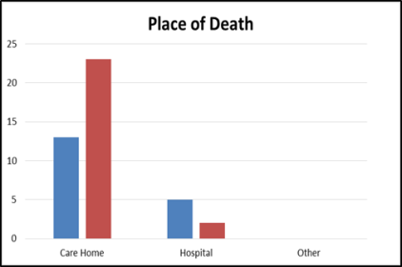

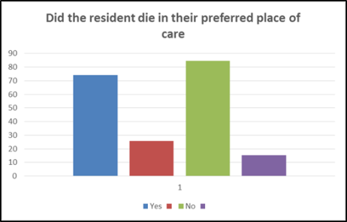

In Dementia care the GSF programme requires evidence of a culture of person centred care for people with varying degrees of impairment /dementia. It provides guidance on creating life enhancing, dignified and safe environments for those living with dementia. It also includes guidance on communication skills, ACP and DNaCPR discussions for those living with dementia.

**EHCH Element 5: Joined up commissioning and collaboration between health and social care.**

GSF has 6 Cross Boundary Care sites across England where training is across all settings and services. These can include Acute Hospitals, Primary Care, Community hospitals, Care Homes, hospice, ambulance service and domiciliary care agencies.

GSF works strategically to encourage commissioners to work on developing integrated commissioning which will in turn help develop integrated care.

Care Homes are considered central to achieving this. Current cross boundary care sires are located in -

* Airedale
* Dorset
* Nottingham
* Barking Havering Redbridge
* Morecombe bay
* Jersey

**EHCH Element 6: Workforce Development**

Prior to beginning GSF training Care Homes are required to complete an organisational questionnaire and a staff confidence questionnaire, which is filled in again on completion of training. Results show a significant increase in staff morale and confidence post training. GSF also shows that Homes who have completed this training, go onto improved staff retention.

Click here for a short film on Staff Retention

To achieve accreditation homes are required to display staff training matrices to show workforce development is in place.

**EHCH Element 7: Data IT and technology**

GSF is a systems based approach and Homes are required to use technology more effectively to improve accuracy and timeliness of record keeping.

This results in better information sharing with GPs and OOHs services, for example by using Skype consultations.