**Master Class in**

**Advance Care Planning**

**The Gold Standards Framework Centre invite you to a Master class seminar on Advance Care Planning with Dr Karen Deterring and Prof Keri Thomas**

**The seminar is aimed at doctors, nurses and others supporting people to initiate advance care planning discussions in the last years of life. We are delighted that the internationally renowned expert in Advance Care Planning Dr Karen Detering will be joining us to discuss ACP in hospitals, primary care, care homes and other settings.**

See ACP section of the GSF website http://www.goldstandardsframework.org.uk/advance-care-planning

Advance Care Planning discussions are recommended as part of UK national policy and form a key part of all GSF Programmes for people in the final years of life, yet many find that this can be hard in practice. This seminar will be an additional support for any teams implementing GSFor focussed on improving EOLC in their setting

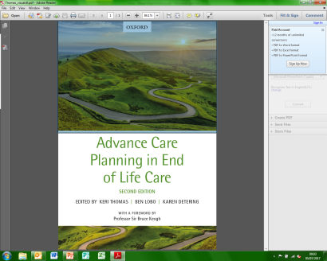Karen is a Respiratory Physician and is the Medical Director of Advance Care Planning Australia, located at Austin Health in Melbourne. This national programme for Advance Care Planning receives funding from the Australian government. She has many years of experience supporting the introduction of ACP across Australia and internationally. Karen is co-editor with Keri Thomas and Ben Lobo of the newly published 2nd edition of the OUP Book ‘Advance Care Planning in End of Life Care’, covering all aspects of ACP which will be available for purchase on the day at a reduced cost

**Date: Thursday October 16th 2018 Time: 10am – 5pm - Lunch provided**

**Venue:** Hospice House, 34‑44 Britannia Street, London.WC1X 9JG (near Kings Cross),

**The programme will include:**

* introductions and international experience of ACP
* experience in different settings
* ACP for people with Dementia
* Skills practice & open discussions

**Cost: £120 *(CPD points applied for)***

***Registration*:** [shanti.shahima@gsfcentre.co.uk](mailto:shanti.shahima@gsfcentre.co.uk) **0207 7893 740**

***Places are limited- please book early***